Name Arfa Iqbal roll no l1s23bscs0295
phase 3
creating database, use,create tables and inserting data
Query

create database IotMonitoringSystem;
use IotMonitoringSystem;
create table location(
locationid int primary key auto_increment,
city varchar(50),
street varchar(50),
postal_code varchar (20),
country varchar(50),
province_or_state varchar(50)
);
create table device(
device_id int Auto_Increment primary key,
devicetype varchar (50),
status enum('active','inactive'),
lastMaintainanceDate date,
powercomsumption float,
locationid int,
foreign key (locationid) references location(locationid)
);
CREATE TABLE Sensor (
sensor_id INT PRIMARY KEY auto_increment,
sensor_type VARCHAR(50),
status VARCHAR(20),
device_id INT,
FOREIGN KEY (device_id) references Device(device_id)
);

CREATE TABLE Threshold (
threshold_id INT PRIMARY KEY auto_increment,
min_value FLOAT,
max_value FLOAT,
sensor_id INT,
FOREIGN KEY (sensor_id) references Sensor(sensor_id)
);

CREATE TABLE SensorData (
data_id INT PRIMARY KEY auto_increment,
timestamp DATETIME,
value FLOAT,
sensor_id INT,
FOREIGN KEY (sensor_id) references Sensor(sensor_id)
);

CREATE TABLE Alerts (
alert_id INT PRIMARY KEY auto_increment,
alert_msg VARCHAR(255),
timestamp DATETIME,
device_id INT,
FOREIGN KEY (device_id) references Device(device_id)
);

CREATE TABLE Users (
user_id INT PRIMARY KEY auto_increment,
first_name VARCHAR(50),
last_name VARCHAR(50),
role VARCHAR(50),
email VARCHAR(100) UNIQUE
);

CREATE TABLE LogManagement (
log_id INT PRIMARY KEY auto_increment,
timestamp DATETIME,
description VARCHAR(255),
device_id INT,
user_id INT,
FOREIGN KEY (device_id) references Device(device_id),
FOREIGN KEY (user_id) references Users(user_id)
);

CREATE TABLE UserDevice (
user_device_id INT PRIMARY KEY auto_increment,
device_id INT,
user_id INT,
FOREIGN KEY (device_id) references Device(device_id),
FOREIGN KEY (user_id) references Users(user_id)
);

INSERT INTO location (locationid, city, street, postal_code, country, province_or_state)
VALUES
(1, 'Karachi', 'Shahra-e-Faisal', '74400', 'Pakistan', 'Sindh'),
(2, 'Lahore', 'Mall Road', '54000', 'Pakistan', 'Punjab'),
(3, 'Islamabad', 'Blue Area', '44000', 'Pakistan', 'Islamabad'),
(4, 'Peshawar', 'University Road', '25000', 'Pakistan', 'Khyber Pakhtunkhwa'),
(5, 'Quetta', 'Jinnah Road', '87300', 'Pakistan', 'Balochistan');

INSERT INTO device (device_id, devicetype, status, lastMaintainanceDate, powercomsumption, locationid)
VALUES
(1, 'AC', 'active', '2024-05-10', 1500, 1),
(2, 'Heater', 'inactive', '2024-06-15', 1200, 2),
(3, 'Fan', 'active', '2024-07-20', 100, 3),
(4, 'Light', 'active', '2024-08-01', 60, 4),
(5, 'Fridge', 'inactive', '2024-04-10', 200, 5);

INSERT INTO sensor (sensor_id, sensor_type, status, device_id)
VALUES
(1, 'Temperature', 'active', 1),
(2, 'Humidity', 'active', 2),
(3, 'Pressure', 'active', 3),
(4, 'Motion', 'inactive', 4),
(5, 'Vibration', 'active', 5);

INSERT INTO threshold (threshold_id, min_value, max_value, sensor_id)
VALUES
(1, 18.0, 28.0, 1),
(2, 30.0, 60.0, 2),
(3, 1000, 2000, 3),
(4, 0, 10, 4),
(5, 0, 500, 5);

INSERT INTO sensorData (data_id, timestamp, value, sensor_id)
VALUES
(1, '2024-11-23 10:00:00', 24.5, 1),
(2, '2024-11-23 10:05:00', 55.0, 2),
(3, '2024-11-23 10:10:00', 1500.0, 3),
(4, '2024-11-23 10:15:00', 5.0, 4),
(5, '2024-11-23 10:20:00', 200.0, 5);

INSERT INTO alerts (alert_id, alert_msg, timestamp, device_id)
VALUES
(1, 'Temperature is too high', '2024-11-23 10:00:00', 1),
(2, 'Humidity exceeded the limit', '2024-11-23 10:05:00', 2),
(3, 'Pressure reading is abnormal', '2024-11-23 10:10:00', 3),
(4, 'Motion detected', '2024-11-23 10:15:00', 4),
(5, 'Fridge malfunction', '2024-11-23 10:20:00', 5);

INSERT INTO users (user_id, first_name, last_name, role, email)
VALUES
(1, 'Ali', 'Khan', 'Admin', 'ali.khan@example.com'),
(2, 'Ayesha', 'Ahmed', 'User', 'ayesha.ahmed@example.com'),
(3, 'Bilal', 'Raza', 'User', 'bilal.raza@example.com'),
(4, 'Fatima', 'Siddiqui', 'Manager', 'fatima.siddiqui@example.com'),
(5, 'Hassan', 'Shah', 'Technician', 'hassan.shah@example.com');

INSERT INTO logManagement (log_id, timestamp, description, device_id, user_id)
VALUES
(1, '2024-11-23 10:00:00', 'Device maintenance completed', 1, 1),
(2, '2024-11-23 10:05:00', 'Device power failure detected', 2, 2),
(3, '2024-11-23 10:10:00', 'Device sensor calibration', 3, 3),
(4, '2024-11-23 10:15:00', 'Device replaced', 4, 4),
(5, '2024-11-23 10:20:00', 'Device firmware update', 5, 5);

INSERT INTO userDevice (user_device_id, device_id, user_id)
VALUES
(1, 1, 1),
(2, 2, 2),
(3, 3, 3),
(4, 4, 4),
(5, 5, 5);

Screenshot:
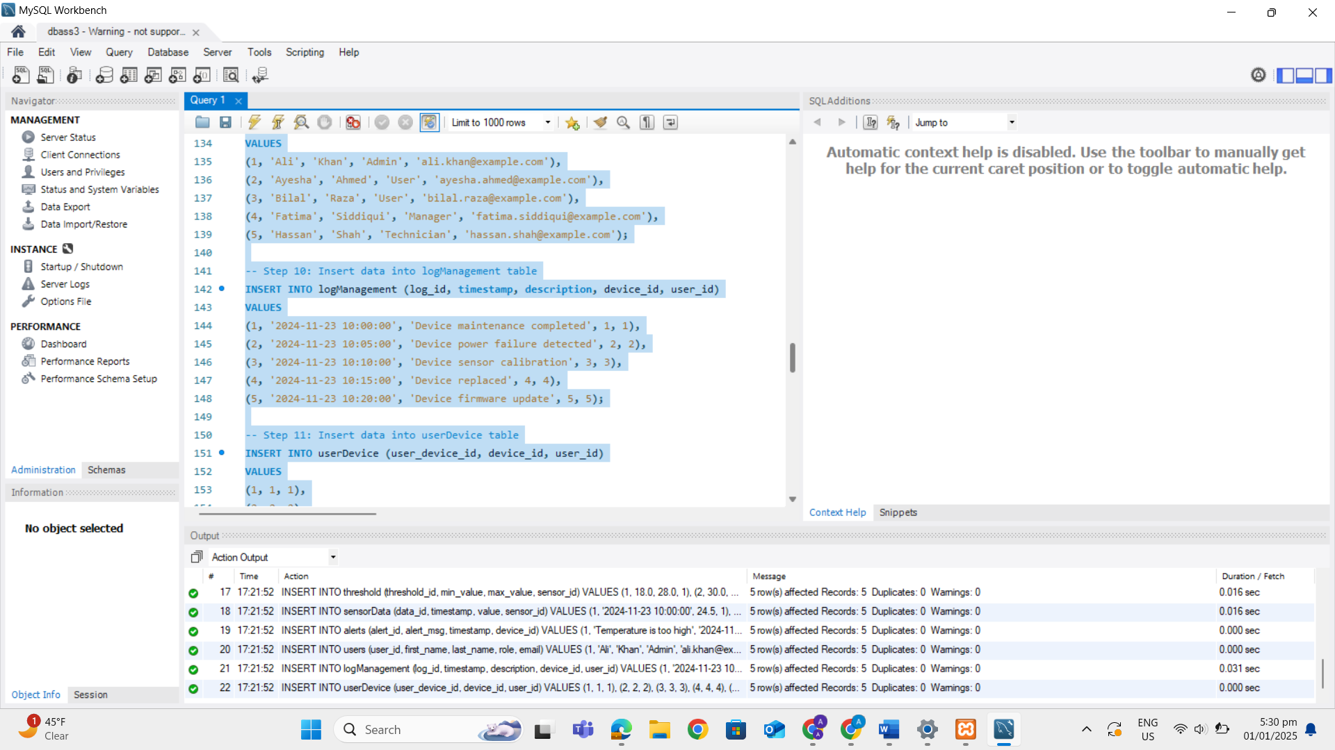

Natural join
SELECT *
FROM location
NATURAL JOIN device;

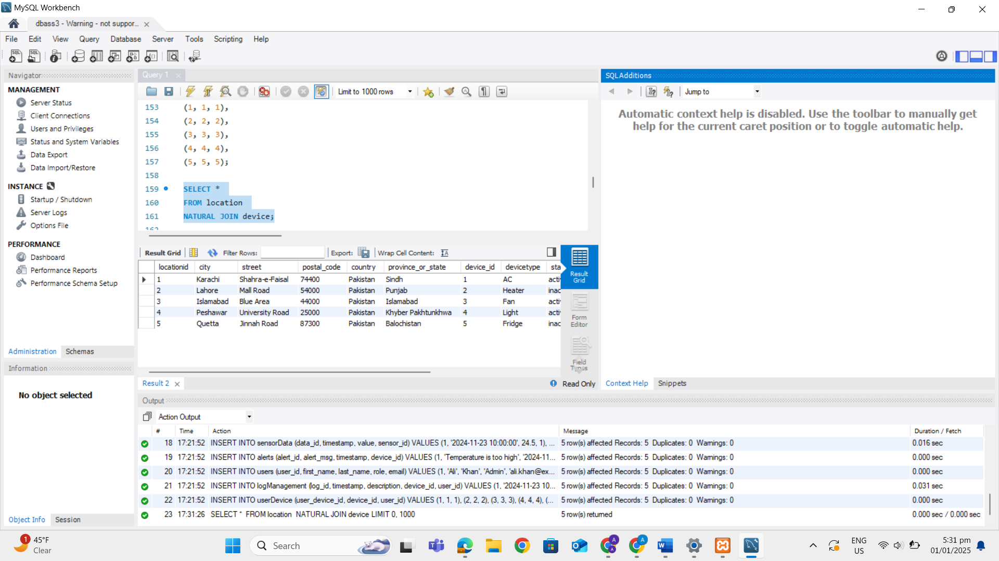

Inner join
SELECT l.city, l.street, d.devicetype, d.status
FROM location l
INNER JOIN device d
ON l.locationid = d.locationid;
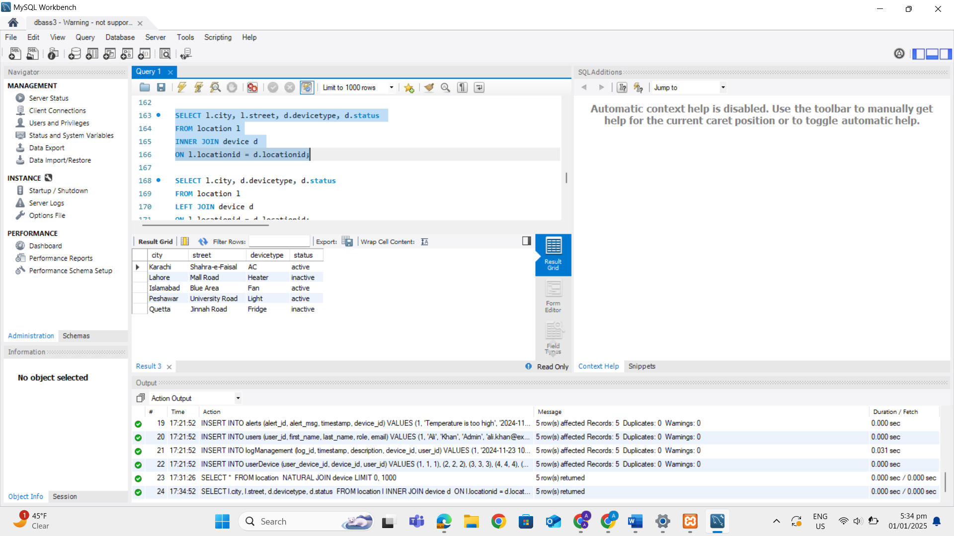
Left join
SELECT l.city, d.devicetype, d.status
FROM location l
LEFT JOIN device d
ON l.locationid = d.locationid;
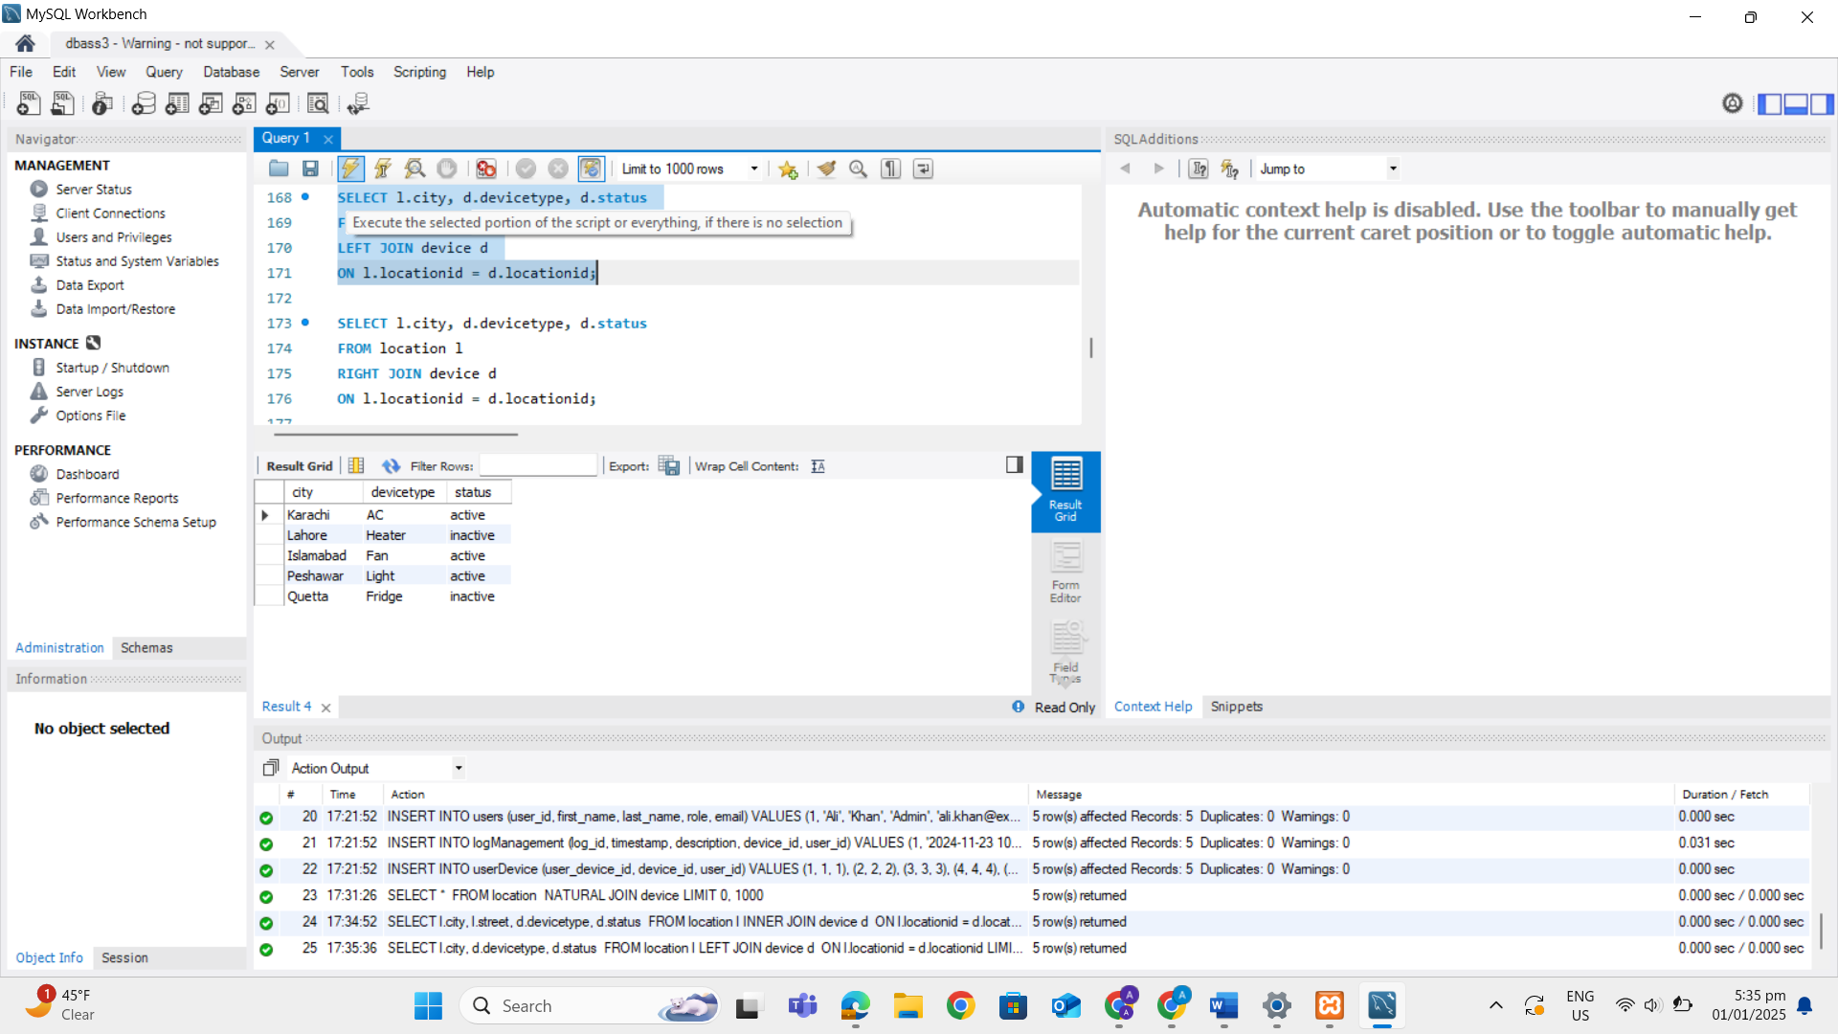
Right join
SELECT l.city, d.devicetype, d.status
FROM location l
RIGHT JOIN device d
ON l.locationid = d.locationid;
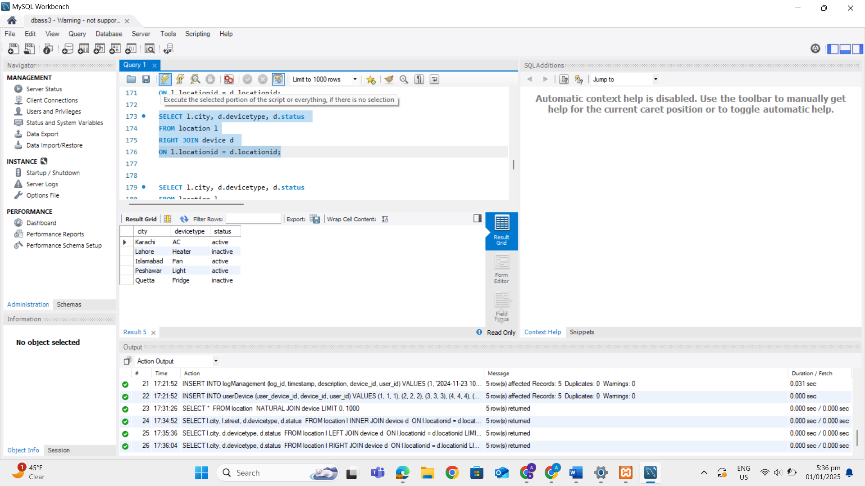
Full outer
SELECT l.city, d.devicetype, d.status
FROM location l
LEFT JOIN device d
ON l.locationid = d.locationid
UNION
SELECT l.city, d.devicetype, d.status
FROM location l
RIGHT JOIN device d
ON l.locationid = d.locationid;
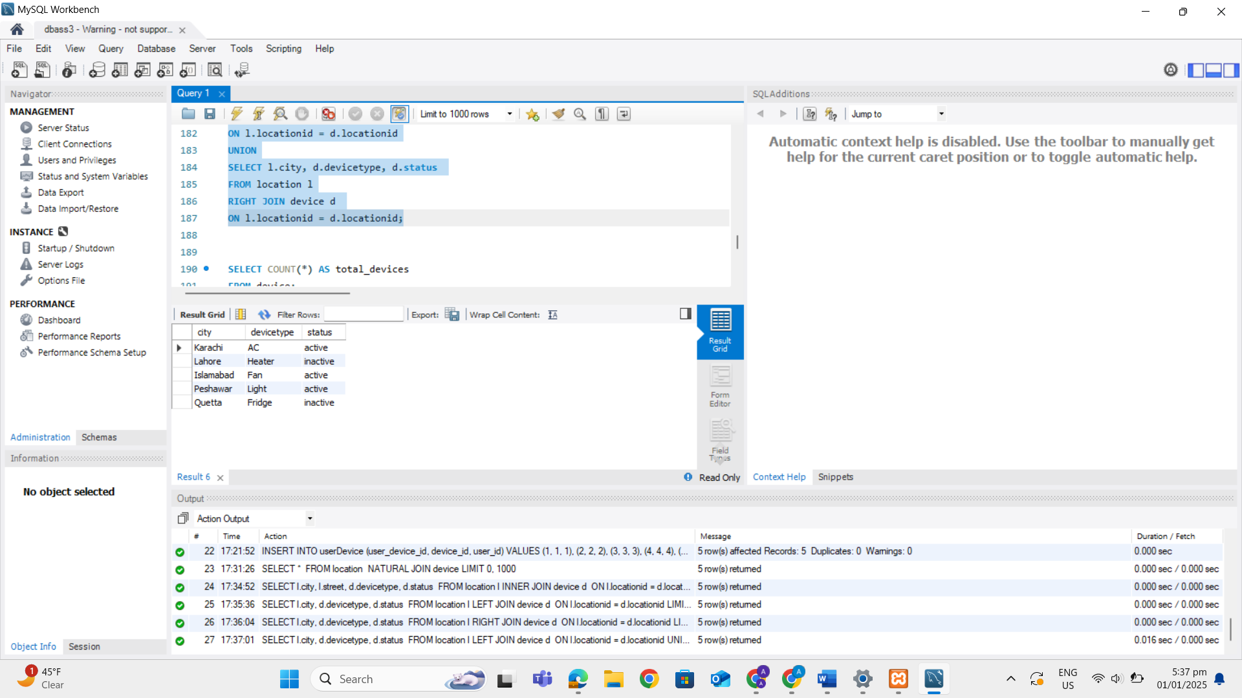

Self join
pairs of users with different roles.

SELECT
U1.user_id AS User1_ID,
U1.first_name AS User1_Name,
U2.user_id AS User2_ID,
U2.first_name AS User2_Name,
U1.role AS Role1,
U2.role AS Role2
FROM
Users U1
JOIN
Users U2
ON
U1.user_id != U2.user_id
WHERE
U1.role != U2.role;

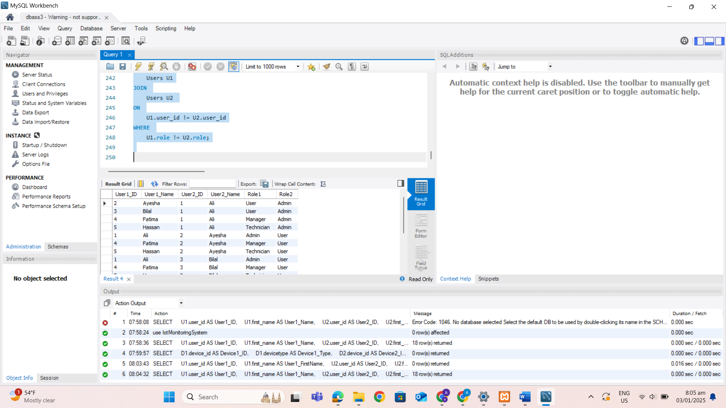

Aggregate functions
Min

SELECT MIN(powercomsumption) AS MinPowerConsumption FROM device;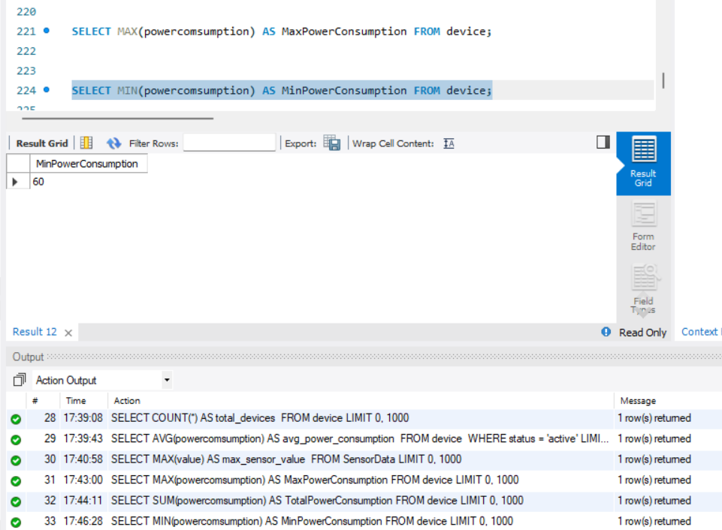

Max
SELECT MAX(value) AS max_sensor_value
FROM SensorData;
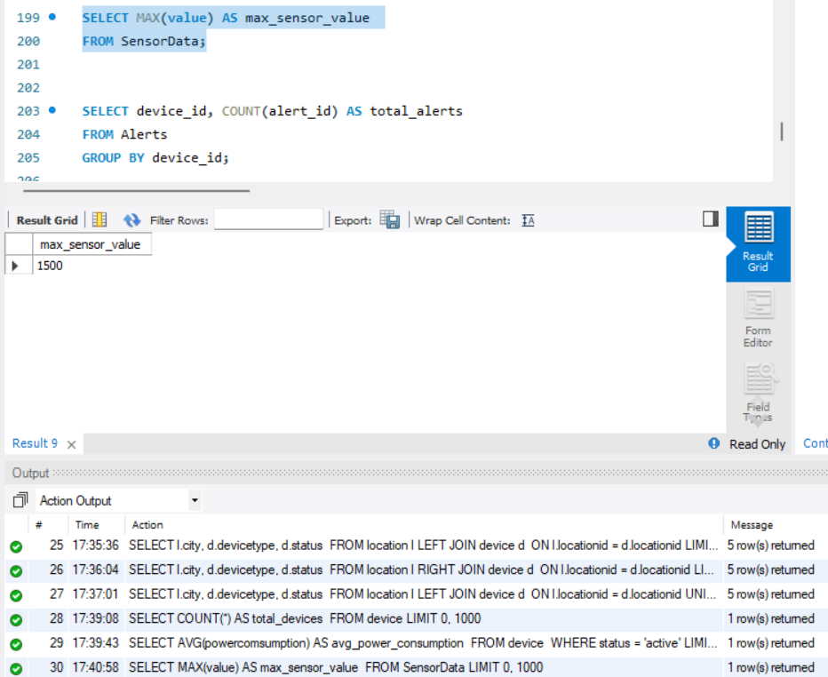
Count
SELECT COUNT(*) AS total_devices
FROM device;
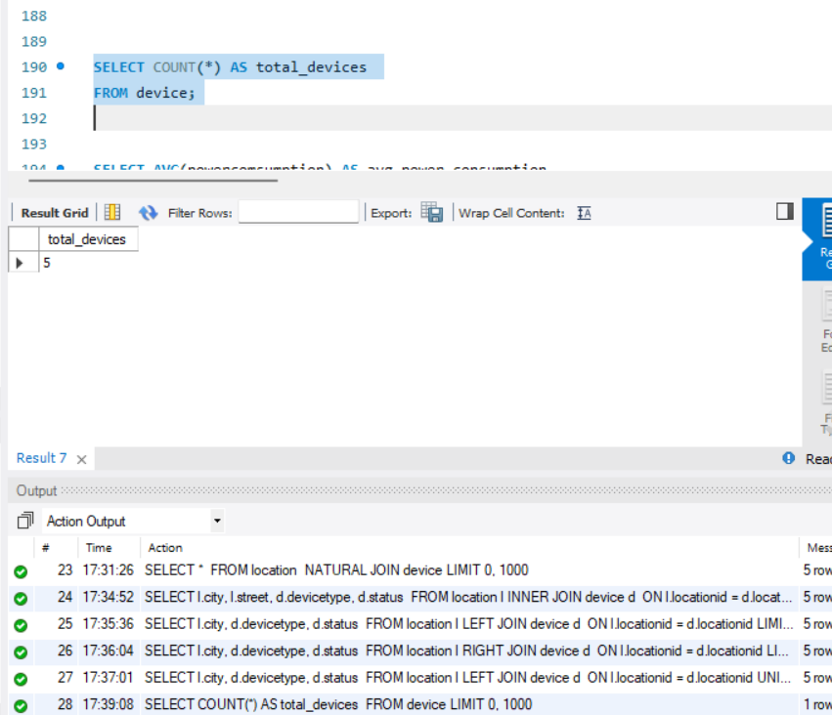
Average
SELECT AVG(powercomsumption) AS avg_power_consumption
FROM device
WHERE status = 'active';
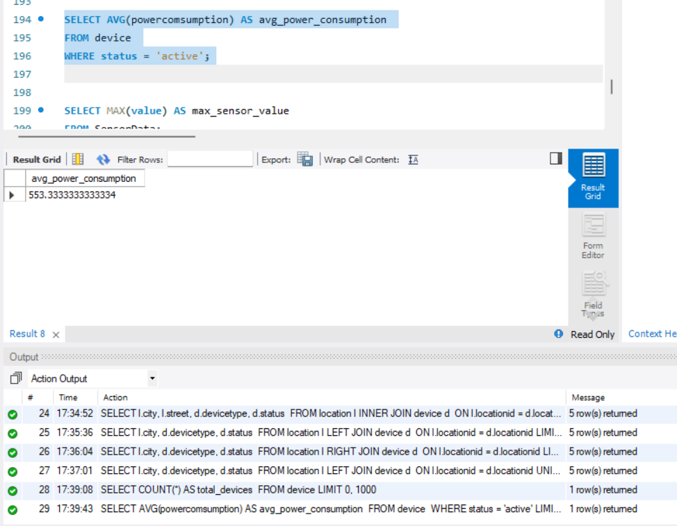
Sum
SELECT SUM(powercomsumption) AS TotalPowerConsumption FROM device;
